Pokhara University

Level: Bachelor | Semester – Fall | Year : 2009
Programme: Architecture |  | Full Marks : 100
Course: Mathematics I |  | Time : 3hrs.

Candidates are required to give their answers in their own words as far as practicable.
The figures in the margin indicate full marks.

Attempt all the questions.

1. | - Define continuity and differentiability of a function f(x) at x = a. Show that the function defines as: 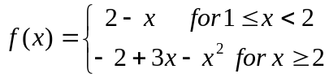 is continuous as well differentiable at x = 2.  - Find for the following functions:  - 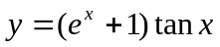  - 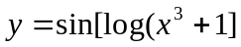  - 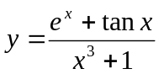  - 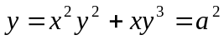 | 7  8
2. | - Show that 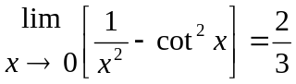  - A cylindrical tin can closed at both ends and of a given capacity has to be constructed. Show that the amount of tin required will be minimum when the height is equal to the diameter.  OR  Define Eulers theorem for a function of two variables. If 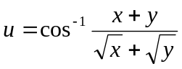, show that 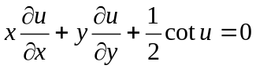 | 7  8
3. | Evaluate any three of the following:  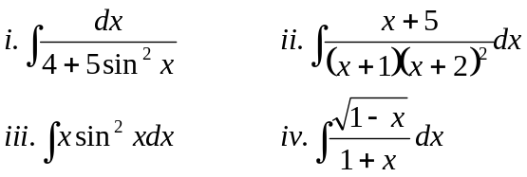 | 15
4. | - Define definite integral as a limit of a sum and hence evaluate 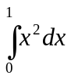by summation method.  - Show that: 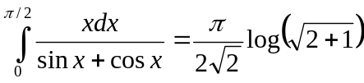 | 8  7
5. | - Sketch the region bounded by the parabola y = x²+1 and the line y = -x+3 and then find its area.  - Find the volume of the solid generated by revolving the region bounded by the curve.  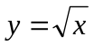below the line y = 1 and x = 4 about the line y = 1. | 7  8
6. | - Find the condition that the line y = mx+c may be a tangent to the ellipse 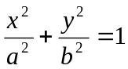.  - Define hyperbola and find its equation in its standard form. | 7  8
7. | Short questions:  - Evaluate 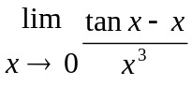  - Integrate 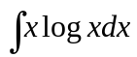  - Find the point of discontinuity of the function 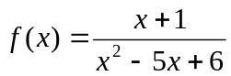.  - If z = x^{1/2}+y^{1/2} , verify. 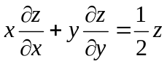  - Find vertex, focus and line of symmetry of the parabola: (y+2)² = 8(x-1) | 10

